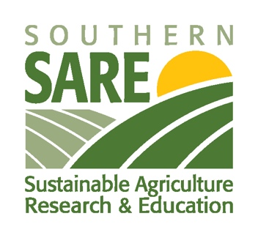

Southern SARE Sponsorship Impact Report

Each individual/organization who receives sponsorship funding support from Southern SARE for conferences, workshops or other educational events must submit an impact report at the conclusion of their event.

The impact report is intended to measure the value of SSARE support in your sustainable ag efforts. Submit your report within 60 days of the completion of your event. Reports not received will impact future sponsorship considerations.

In addition to the impact report, the organizer/institution must also provide SSARE a copy of the event agenda or event flyer that acknowledges SSARE representation at the conference/event.

Submit the impact report and event agent/flyer to Tydaisha White at tydaisha.white@uga.edu.

Name of Individual/Organization:

Name and Date of Event:

How did SARE funding assist your ability to serve your community per the event that you conducted?

How did the event benefit farmers? Provide any information as it relates historically underserved farmers and ranchers.

How did the funding help further sustainable agriculture in your community?

